**C++ library management project :**

**Members :**

**Kulzum mujtaba(20k-0220)**

**Muhammad zubair (20k-0465)**

**Why library management system?**

To improve library use services

To reduce paper work

Book wise search can be performed

More accuracy

**Problem statement :**

We decided to work on this project as we see the following problems occurs

In the library management due to manual management still in this computer era .

Time consuming

Searching records is a challenging work

Cant access to the resources available immediatley

Maintaining registers is complex

Updating records is a tedious work

**Solution :**

The system will allow performance of the actions needed in order to manage the library in a simple and comfortable way .The actions will be included addition of books ,book searches and many more .The administration in parallel to user actions keeps a basic security level which prevents the access or modifications of data by user which don’t possess the proper permission .

**Programming concepts use**

The concepts implemented in our library management system includes

Classes , inheritance (heirarchial ), composition (has a relationship ), filing (the most import part of the project),encapsulation,abstraction ,friend function, arrays,conditional statements , data hiding ,default explicitly called constructors

**Libraries used:**

#include<iostream>

#include<stdio.h>

#include<string.h>

#include<fstream>

#include<iomanip>

#include<conio.h>

#include<stdlib.h>

**Key features:**

Main menu

Search menu

**For students :**

Search book(by book id or book title)

Issuance of books

Display issued books

**For administration:**

Requires password

Search book(by book id or book title)

Modify book details

Add book

Display all books

Issue books

**Class Inheritance:**

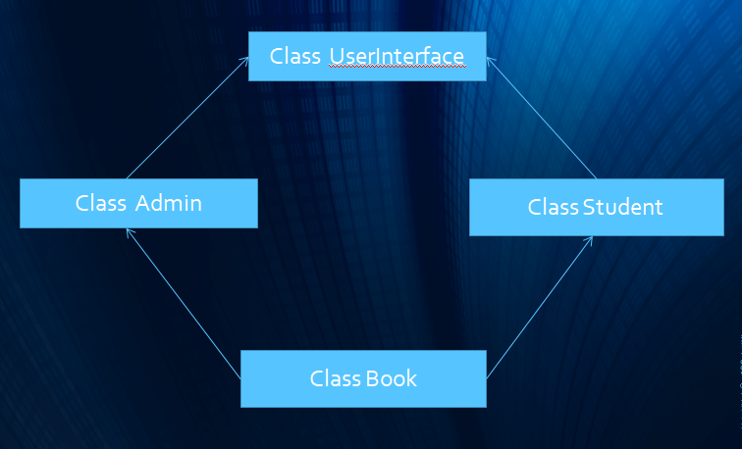

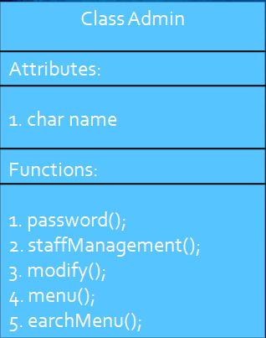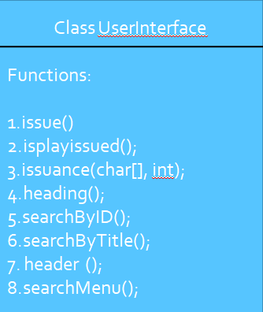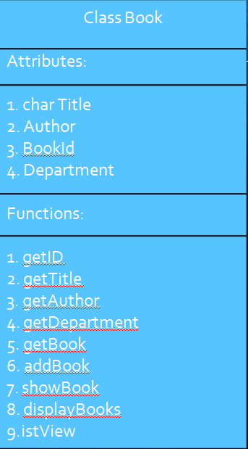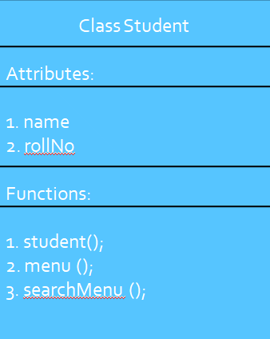**Class Diagram:**